# DAILY ONLINE ACTIVITIES SUMMARY

|  |  |  |  |  |  |  |  |
| --- | --- | --- | --- | --- | --- | --- | --- |
| **Date:** | **31-05-2020** | | | | **Name:** | **Apoorva H P** | |
| **Sem & Sec** | **VI A** | | | | **USN:** | **4AL17CS011** | |
| Online Test Summary | | | | | | | |
| **Subject** | | **No(Sunday)** | | | | | |
| **Max. Marks** | |  | | **Score** | |  | |
| Certification Course Summary | | | | | | | |
| **Course** | **Machine Learning with Python** | | | | | | |
| **Certificate Provider** | | | **Congnitive Class** | **Duration** | | | **6hr** |
| Coding Challenges | | | | | | | |
| **RPA – Robotic Process Automation-3hr** | | | | | | | |
| |  |  | | --- | --- | | **Uploaded the report in GitHub** | **Yes** | | **If yes Repository name** | <https://github.com/ashaapoorva/online-coding-and-certification-course> | | **Uploaded the report in slack** | **Yes** |   **Status: Completed** | | | | | | | |

**Online Certification Details**

Module completed:

Module 3:Classification

-Learning objectives

-Intro to Classification

-K-Nearest neighbors

-Evaluation Metrics

-Intro to decision trees

-Building decision trees

-Intro to logistic regression

-Logistic vs linear regression

-Support vector machine

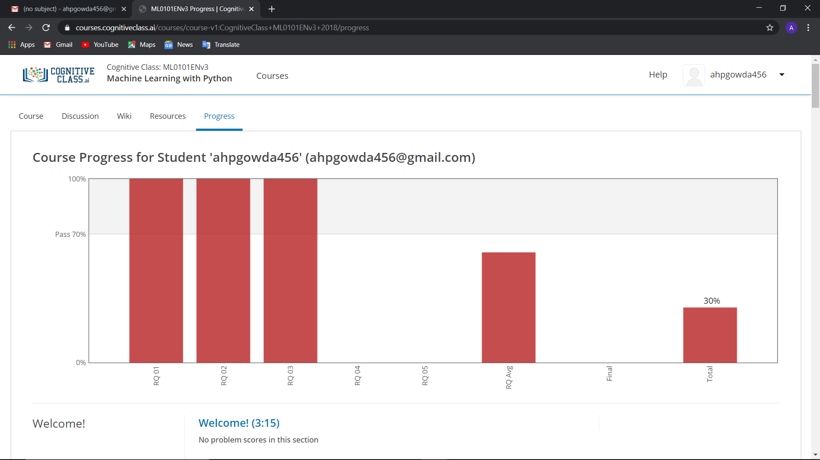

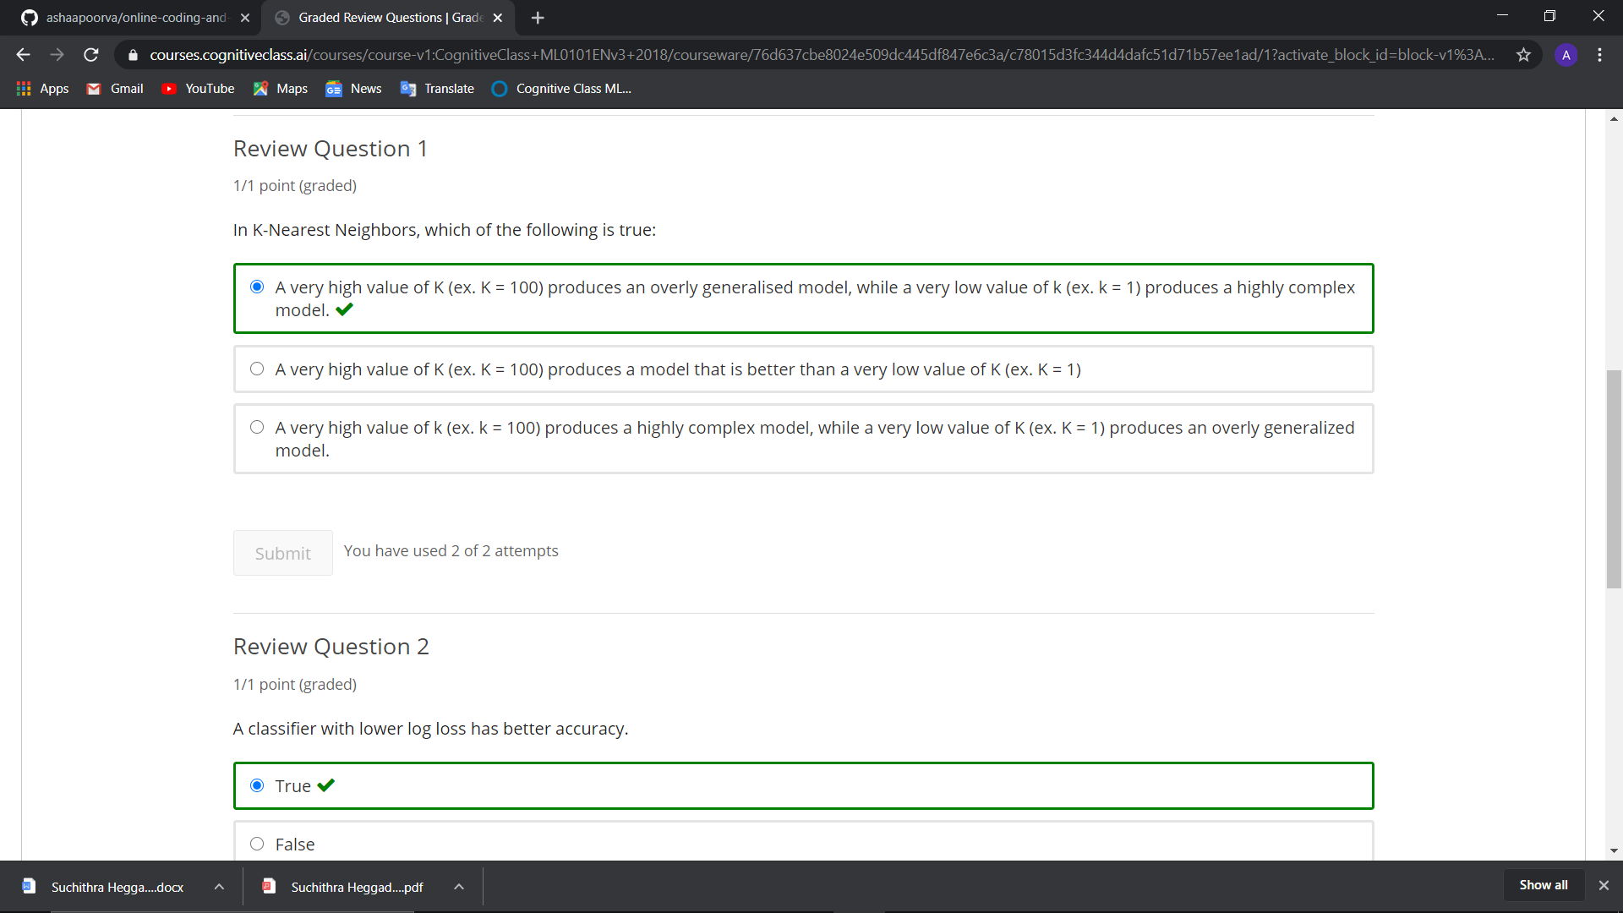

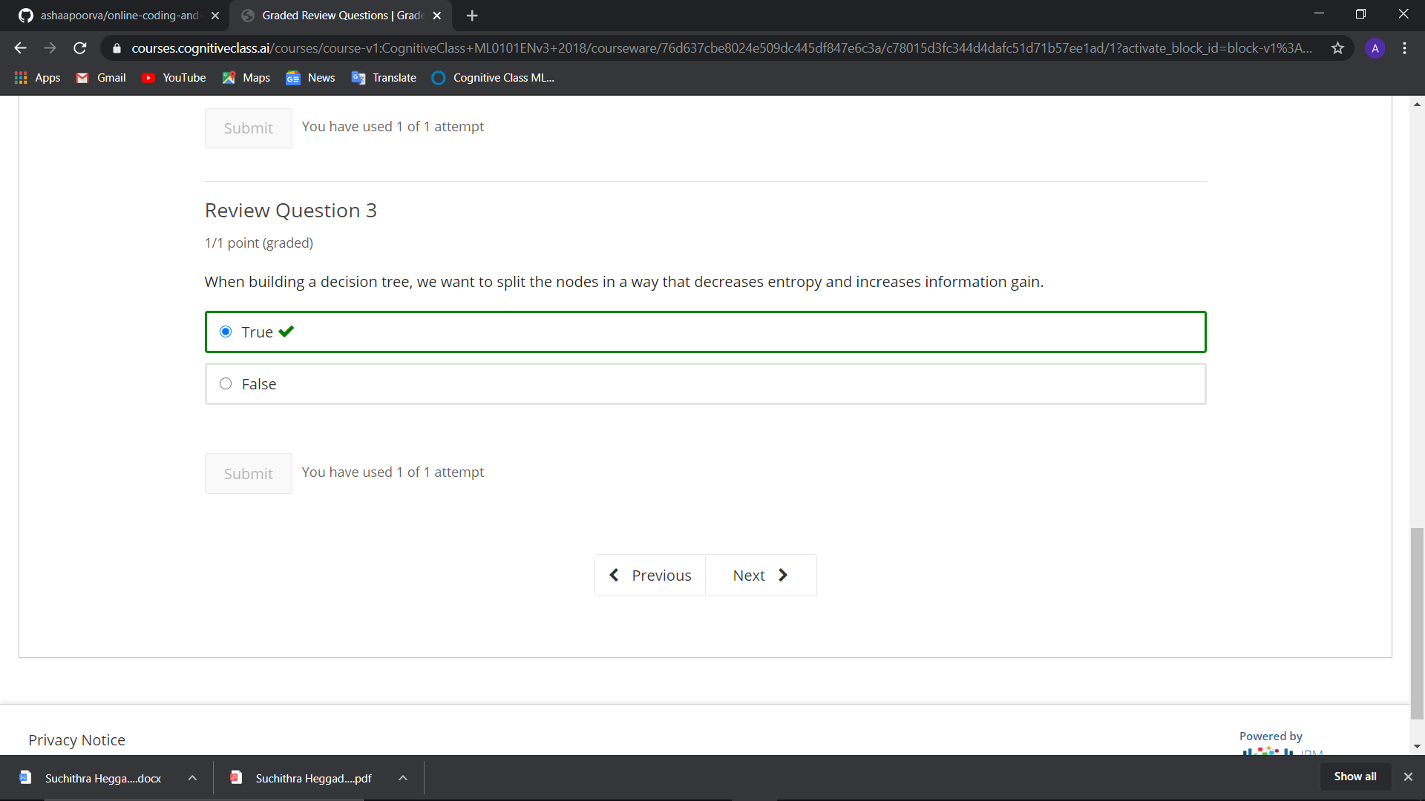

RPA – Robotic Process Automation.

